|  |  |
| --- | --- |
|  |  |

AI-Driven Skin Cancer Detection: A Comprehensive Review of Deep Learning Techniques for Early Intervention

Abhishek Waghchaure1, Deepali Pankaj Javale2

1 Dr. Vishwanath Karad MIT World Peace University, Pune, India

Email: [abhisw28@gmail.com](mailto:abhisw28@gmail.com)

2Dr. Vishwanath Karad MIT World Peace University, Pune, India

Email: [deepali.javale@mitwpu.edu.in](mailto:deepali.javale@mitwpu.edu.in)

**Abstract**—This research paper comprehensively explores AI-driven skin cancer detection for early intervention, employing deep learning techniques. The study incorporates diverse literature surveys, utilizing various technique analyses to assess the effectiveness of the proposed approach. Using convolutional neural networks (CNNs), the model demonstrates promising capabilities in accurately identifying and classifying various skin cancer types. The literature surveys encompass many sources, offering a thorough understanding of existing methodologies and advancements in the field. The paper aims to contribute valuable insights into the intersection of dermatological research and machine learning, emphasizing the significance of early detection in improving patient outcomes. Incorporating different technique analyses enhances the robustness of the research findings, providing a nuanced perspective on applying deep learning in skin cancer diagnosis.

Index Terms**—Skin cancer, AI, Deep Learning, Machine Learning, CNN**

I. Introduction

The term "cancer" traces its origins to the ancient Greek words "kapkivoc," signifying crab, and "tumor." First introduced to the medical realm in the 1600s, cancer is characterized by the abnormal growth of cells with the potential to infiltrate or disperse throughout the body. Uncontrolled cell division is the first step at a specific site and may progress to other body regions, known as cancer metastasis. Cells are broadly categorized into benign, which do not spread, and malignant, which metastasize and pose a more significant threat [1]. With its high mortality and recurrence rates, cancer treatment is prolonged and costly, necessitating early and accurate diagnosis to improve patient survival rates [2]. Cancer is a genetic disease triggered by mutations controlling cell functions, particularly growth and division. Additional genetic alterations ensue with the proliferation of tumor cells, leading to more mutations than normal cells. Although the immune system often eliminates damaged or aberrant cells, specific cancer cells can elude detection [3].

Furthermore, cancers leverage the immune system to promote their survival and proliferation. The origin of cancer kinds is governed by the anatomical place where the cells originate. Lung cancer begins in the lungs and can spread to the liver [4].

Cancer diagnosis involves three prognostic elements: estimating survival, predicting cancer recurrence, and determining the likelihood of cancer occurrence. This intricate technique entails assessing the cancer risk, recurrence, survival, advancement, life expectancy, and tumor drug sensitivity [5]. Advancements in predictive modeling and diagnostic techniques are crucial in enhancing our understanding and management of this complex disease. State-of-the-art technology is crucial in healthcare for promptly identifying and managing serious disorders. An AI-powered skin cancer diagnosis project that utilizes deep learning to revolutionize the field of dermatology is an illustrative attempt. Skin cancer is a common and potentially fatal disease that poses a significant global health challenge [6]. Scholars suggest using Convolutional Neural Networks (CNNs) to detect various types of skin cancers in their early phases as a new approach in research. The project's core is a robust algorithm extensively trained on the HAM10000 dataset, consisting of 10015 high-resolution dermatoscopic images collected from diverse populations [7].

The AI model aims to accurately predict different types of skin cancers, including actinic keratoses, intraepithelial carcinoma, basal cell carcinoma, benign keratosis-like lesions, dermatofibroma, melanoma, melanocytic nevi, pyogenic granulomas, and hemorrhage, using the CNN architecture [8]. The model's impressive accuracy rates demonstrate its potential as a reliable tool for early diagnosis. Our project aims to improve patient outcomes by increasing awareness of risk factors related to skin cancer and emphasizing the importance of early detection [9]. Merging machine learning and dermatological research leads to substantial advancements and sets the foundation for future medical image categorization and analysis discoveries. The HAM10000 dataset, which is publicly available and includes a diverse collection of dermatoscopic images, serves as a valuable resource for collaborative efforts in skin cancer identification [10].

The AI-powered skin cancer detection initiative signifies a substantial advancement towards a future in which technology plays a critical role in augmenting the decision-making capabilities of healthcare practitioners [11]. This, in turn, will result in improved patient care, earlier detection of cancer, and favorable health outcomes on a global scale.

The paper is meticulously structured to explore skin cancer recognition techniques comprehensively. Section II provides an insightful review, delving into various methodologies, including artificial intelligence, machine learning, deep learning, and CNN. This section serves as a foundation for understanding the intricacies of the subject matter. Moving forward, Section III presents a detailed analysis of these techniques in a tabular format, facilitating a clear and organized comparison. Finally, Section IV synthesizes the findings and draws meaningful conclusions, culminating the paper with valuable insights and potential implications for future research.

II. Review Of Various Skin Cancer Recognition Techniques

## A. Artificial Intelligence

Innovative analytical approaches have emerged in digital pathology, extracting novel insights from standard histology for treatment guidance and biomarker development in clinical oncology. AI has significantly influenced drug discovery, design, and optimization, offering new dimensions like modulated dosing. To leverage these advancements effectively, seamless workflows integrating AI innovation are crucial for enhancing diagnostic and interventional capabilities. Despite challenges, recommendations spanning clinical, engineering, implementation, and healthcare economics realms aim to facilitate the sustainable adoption of AI in clinical oncology. The ultimate goal is to drive positive patient outcomes through the transformative integration of AI technologies. [12, 13]

Based on MoleMap Ltd and Monash eResearch research, an AI algorithm for skin lesion classification can determine if a lesion is benign, malignant, or unsure. The treating physicians in this pre- and post-intervention trial must learn about the artificial intelligence lesion evaluation conducted before the intervention. After the procedure, physicians can monitor AI-generated lesion evaluations in real-time to fine-tune their diagnosis and treatment plans. Check for suspicious skin lesions as well as two noncancerous ones. By comparing the AI algorithm's sensitivity and specificity to existing histology or the classifications made by treating consultant dermatologists, determine whether it is safe after the preintervention time has ended. Ultimately, the teledermatologist, registrar, treating dermatologist, and histopathologist will compare their classifications with the AI's.[14]

In this trial, which includes pre-and-post-intervention phases, treating physicians must be informed about AI lesion assessments before the intervention. After the intervention, clinicians can use the AI lesion assessments that were done in real-time to make adjustments to their diagnosis and treatment plans. All participants will undergo imaging to detect potentially malignant skin lesions and two benign lesions. Registrars, treating consultant dermatologists, and, eventually, teledermatologists all play a role in lesion evaluation. After the preintervention time, the AI algorithm's safety will be assessed by looking at its sensitivity, specificity, and how well it agrees with the available histology or the classifications made by the treating consultant dermatologists. After the AI classifications are finished, they will be compared to the registrar's, treating dermatologists, histopathologists, teledermatologists, and their own. Compare the registrar's original decision to determine how the AI algorithm affected the registrar's diagnostic and management choices. [15, 16]

An efficient search for the research publications in this research that anticipated cancer using AI-based learning methods. 185 publications are significant for deep learning and conventional machine classifications used in cancer prediction [17]. Furthermore, the survey discussed the research conducted by various researchers and emphasized the shortcomings of the literature that has already been published. Five studies have been conducted, and possible solutions have been considered. Cancer mortality has not decreased despite the fantastic prediction outcomes of several techniques suggested in the literature. Therefore, further investigation is needed to address the issues.[18]

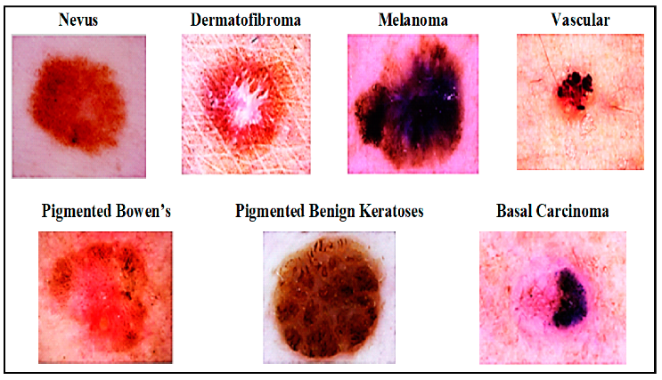

## Figure 1. Skin Cancer Detection

The vital need for early diagnosis for successful treatment of skin cancer, which continues to be a significant global health concern, is highlighted by this. Unfortunately, developing nations have less access to the technique and pay more for skin cancer specialists [19, 20]. The demand for automated diagnostic systems is increasing to meet this problem. Potentially lowering mortality and morbidity rates, approaches based on artificial intelligence (AI) have been suggested to aid in the early diagnosis of skin cancer. With an eye on deep learning and machine learning, this survey delves into their potential uses in skin cancer diagnostics. Automated skin cancer diagnosis is the subject of this comparison of popular datasets and renowned review articles. Finally, the study discusses potential future paths and scope after delving into lessons and insights from previous works. These findings should help with future difficulties with automated skin cancer diagnosis.[21]

The diagnostic has been established in experimental research, particularly melanoma. Understanding patients' perspectives bridges the gap between experiments and clinical applications. In Germany, a survey was conducted focusing on individuals with a family history of skin cancer [22, 23]. The online survey was emailed to melanoma support groups and academic medical centers and promoted on social media to assess patients' views on AI in melanoma diagnostics. The anonymous survey explored expectations, concerns, and attitudes toward AI application scenarios. Descriptive analysis employed 95% confidence intervals to represent categorical variables as percentages, while statistical tests investigated the connections between questionnaire responses and sociodemographic data [24].

While mHealth applications that use artificial intelligence (AI) to categorize problematic skin lesions have been developed, little is known about how these systems would be affected [25]. A prominent Dutch health insurance provider provided 2.2 million adults with a free mobile health app in 2019 that could identify skin cancer. A pragmatic study that looked back at the population to see how it affected dermatological healthcare usage. They analyzed dermatological claims made in the first year following free app access by 18,960 mHealth users who had completed at least one evaluation and 56,880 control users who had not used the app using odds ratios (OR). A short-term cost-effectiveness study determined costs per additional discovered (pre)malignancy. Compared to the current standard of care, the app detected one more (pre)malignant skin lesion for €2567. The outcomes indicate that AI in mHealth can aid in detecting more cutaneous (pre)malignancies; however, this advantage should be evaluated against the more significant increase in care utilization for benign skin tumors and nevi, which is now more widespread. [26]

To effectively track nevi that exhibit traits that can suggest the existence of melanoma, provide an AI-based detection approach that uses deep learning techniques. The model was developed using a thorough dataset that included 8598 photos. Following the procedures outlined in the most recent research, the dataset was trained, validated, and tested using ResNet, AlexNet, MobileNet, VGG16, and VGG19 algorithms. After completing the testing and training phases, the MobileNet model outperformed the other algorithms with an accuracy of 84.94% [27]. They plan to build a functional detection system by combining this model with a desktop application with different operating systems. The proposed approach might help melanoma specialists in their diagnostic work. [28]

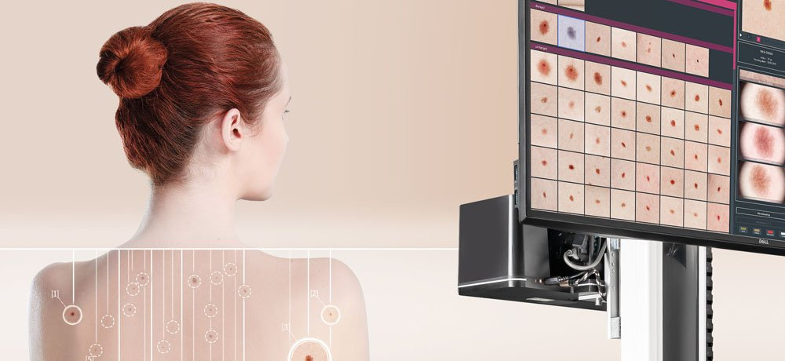

## Figure 2. AI-Based Detection

A new age of better health is dawning on the healthcare business due to the dramatic shift brought about by the application of AI for early cancer detection. The prospective influence of AI on preventive healthcare via early illness identification is investigated in this review paper, which delves into the new paradigm that AI has introduced. This framework leverages AI's computational capabilities to analyze complex medical data, such as health records and imaging tests, and identify previously imperceptible indicators of sickness. Enhancing the precision of diagnosis and emphasizing early detection is crucial. Artificial intelligence surpassed traditional methods in speed and accuracy for detecting abnormalities in a meta-analysis of investigations. This change will result in shorter treatment times and better patient results. At the heart of this paradigm change is AI's potential to transform healthcare by detecting and fixing treatable health problems before they happen. [29]

An artificial intelligence system integrating algorithms for image analysis, computer vision, and machine learning could potentially diagnose skin cancer. An artificial intelligence system integrating algorithms for image analysis, computer vision, and machine learning could potentially diagnose skin cancer [30]. With this innovation, early detection of skin cancer is now possible. AI-powered skin examinations are faster and more accurate than human dermatologists and general practitioners. A doctor may be able to use this technology to spot invisible irregularities in the human eye, allowing them to pursue further investigation or implement necessary corrections. Additional tests or treatments may need to be considered if artificial intelligence cannot spot patterns in a patient's medical records. Compared to human doctors, artificial intelligence (AI) is light years ahead when it comes to problem detection and recommendation making. Regarding reducing death rates, AI-assisted diagnostics can be a lifesaver in early skin cancer detection before it spreads. Thanks to AI-powered solutions, early skin cancer screening is now easier and faster. Artificial intelligence (AI) could substantially improve skin cancer diagnosis by developing intelligent decision-support systems and the automated analysis of digital images. To guarantee patients receive timely treatment, medical practitioners should take preventative actions by utilizing AI to identify and diagnose skin cancer in its early stages. [31]

One of the most pressing global health concerns is the prevalence of skin cancer. Skin cancer is curable with prompt diagnosis and treatment. The existing method necessitates the participation of skin cancer experts, which renders the operation costly and inaccessible in underdeveloped nations, even though early detection is critical for an effective cancer cure. Because there are not enough dermatologists, computerized diagnosis tools for skin cancer have become necessary. These methods can aid in the early diagnosis of skin cancer, which in turn reduces the disease's morbidity and fatality rates. Artificial intelligence subfields, known as machine learning and deep learning, focus on statistical modeling and inference; these methods iteratively learn from input data to forecast goals and traits. They are keeping a healthy mix of the two. The article compares automated skin cancer diagnosis to commonly used datasets and review papers. Insights and lessons gained from previous research are also covered in the study. To overcome the obstacles encountered in automated skin cancer diagnosis, the study concludes by discussing potential future directions and scope.[32]

Despite assertions to the contrary, deep learning algorithms still face significant obstacles on the path to full diagnostic capability when it comes to skin cancer diagnosis. Algorithms are never tested in diagnosing skin cancer patients since these tests are conducted in controlled environments. When diagnosing in the real world, it is essential to consider the patient's ethnicity, hair, eye, and skin color. Examining the patient's clinical history and how they responded to past treatments is also helpful. On the other hand, image data is the mainstay of present-day deep learning models. Furthermore, a misdiagnosis is expected when these algorithms are used for skin lesions or disorders not included in the training dataset. This research delves further into potential avenues for developing robust algorithms to aid doctors in diagnosing skin cancer. Methods for skin cancer diagnosis, computer vision, and dermatological associations should collaborate to improve present AI solutions. [33]

Finding and categorizing the many AI-based studies is the primary aim of this study, which is to construct systems for identifying and categorizing skin cancer. The study also looks at the dependability of the chosen publications. The use of AI in healthcare has made skin cancer diagnosis much more accessible. However, the trustworthiness of most AI techniques is questioned due to the use of tiny datasets or a low number of diagnostic classifications. Furthermore, different methods use different evaluation measures and image kinds, which makes it hard to compare them directly. [34]

## B. Machine Learning

An Android app that detects skin cancer using ML and a trained MobileNet V2 model has demonstrated encouraging outcomes. The app's intuitive design makes uploading an image for evaluation simple. The analysis's results are presented straightforwardly and accurately, regardless of whether they are benign, malignant, or healthy. A more rapid and accurate skin cancer diagnosis is now feasible because of advancements in machine learning, which have substantially accelerated the process. This study's findings provide new opportunities for medical field research and development by demonstrating the potential of integrating mobile technologies and machine learning. [35]

The field of dermatology is rapidly adopting AI. However, better global skin imaging collaboration is the only way to collect the clinical and photographic data needed for AI research, which includes all skin types. It is necessary to record the sensitivity, specificity, and performance in prospective studies and real-life situations. Dermatologists should not worry that AI will replace their knowledge; instead, they should prepare to regard it as a valuable tool to enhance their clinical practice in the following years. Dermatologists, in practice, can improve skin care by learning more about AI concepts. Safeguarding patient information, obtaining massive datasets, and teaching AI algorithms to make more accurate diagnoses are all obstacles to using AI to detect skin cancer. Patients appear to have a favorable impression of AI for melanoma diagnosis based on the scant evidence from survey-based studies. These areas require additional investigation. [36]

Thanks to the technological advancements of the era, AI-ML has thrived. These groundbreaking discoveries were once reserved for non-medical uses, but they are now finding their way into healthcare systems all around the globe. The healthcare industry is already seeing and will continue to see profound changes brought about by AI and ML. Oncology has enormous untapped potential that could revolutionize cancer detection, prognosis, and treatment, among many other areas of cancer research. One of the deadliest diseases, cancer, may soon have a cure. Still, until then, finding ways to prevent the disease in the first place is more critical, which means developing better methods. This article covers new advances in ML, AI, and deep learning. A more successful cancer treatment may be possible thanks to integrating DL, ML, and AI into various diagnostic and predictive tools. It may one day make hospitals better places to treat any illness, not only cancer. One day, with the aid of these ever-improving algorithms, and conquer the challenges posed by this crippling disease. Further research is necessary to maintain clinical usefulness and analytical and clinical validity in light of these goals. [37]

This systematic review of skin cancers globally focuses on AI/ML algorithms for early diagnosis in primary and community care settings. Examining 14,224 studies from Jan 1, 2000, to Aug 9, 2021, the review found reasonable diagnostic accuracy for melanoma (89.5%), squamous cell carcinoma (85.3%), and basal cell carcinoma (87.6%). However, more data from low-prevalence clinical settings would allow broad adoption in primary care. The secondary outcomes reveal diverse AI/ML methods and study designs with incomplete reporting. No health economic, patient, or clinician acceptability data were identified. The study proposes a checklist for developing AI/ML algorithms, emphasizing the need for efficacy in low-prevalence populations before widespread adoption in community and primary care settings. [38]

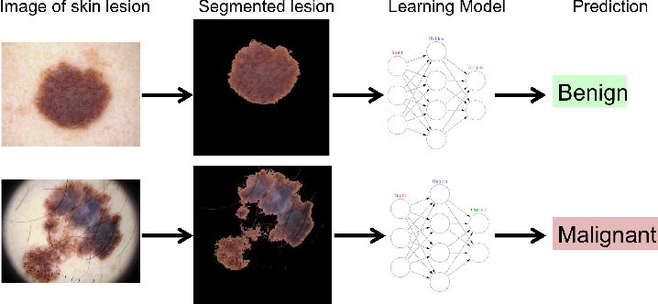

## Figure 3. Vision-Based Classification of Skin Cancer Using Dl

## C. Deep Learning Approach

Overfitting occurred in the present study since CNN was fed more than 200,000 pictures, which led to inaccurate results. Contrarily, prior research found that 30,000 photos of skin lesions were the upper limit. Enhancing future DL algorithms to eradicate the overfitting problem will be necessary. Autoencoder and optimization techniques are still necessary for some DL algorithms to reach optimal accuracy. The study's long-term goal is to dissect the significance of DL models in healthcare via the extensive data network. Researchers also found that, without any confounding variables, image resolution did not affect image specificity, sensitivity, or accuracy. This study successfully sheds light on the function of CNNs in precisely diagnosing cancerous lesions.[39]

The subjective nature of the results, the high cost, and the complexity of skin cancer diagnosis have all contributed to its status as a significant issue for modern medicine. The likelihood of successful treatment depends on early identification, which is especially important in life-threatening cases like melanoma. As a result, early diagnosis requires automated systems, especially when dealing with diverse image samples displaying varied diagnoses. This study compared the current gold standard of medical staff-based detection with an automated image analysis approach to identify dermatological illnesses. One potential use of a deep learning-based automated system for skin cancer detection and classification is in medicine, where early detection is crucial. The ISIC dataset, which contains numerous images of skin disorders, presents a perfect opportunity to develop. The proposed method could affect the medical industry by making doctors' jobs more accessible while providing fast, accurate diagnoses.[40]

Dermatology image categorization and cancer prediction have both been significantly advanced by artificial intelligence (AI) in recent years. The diversity of models, images, database features, and outcome measures makes it challenging to generalize AI's potential use in clinical dermatology. This systematic review will use convolutional neural networks to summarise the dermatology literature thoroughly. The current status of picture datasets, transfer learning methods, issues, and constraints in the artificial intelligence literature are also discussed, as are the current procedures for model approval as clinical decision support tools. [41]

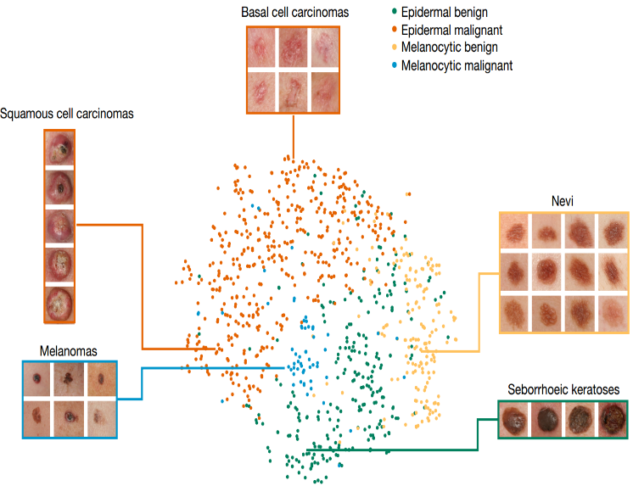

## Figure 4. DL Algorithm

This study investigates the feasibility of a tailored melanoma detection system. They have created a melanoma detection algorithm that uses deep learning to classify patients' skin lesion photos and provide a reasonably accurate diagnosis of melanoma. The results showed that the best classifier, utilizing two CNNs and one RNN with attention, outperformed the external benchmark by about 5% when testing with 5 lesion photos per patient. This system combines machine learning classifiers with standard clinical practitioner methods to offer comprehensive suggestions by utilizing patients' unique biological signs. Classifier models have been an enormous success, but there is still a way to go before customized healthcare fully functions; problems like picture quality necessitate more investigation. On the other hand, this model can be used as a starting point for future research to refine and enhance to create a healthcare application for individualized melanoma diagnosis that is better and more convenient. [42]

While deep learning algorithms have gained popularity as a solution, dermatologists still do not trust them because they cannot understand or verify the models' judgments. This research proposes a skin lesion classification system that uses explainable artificial intelligence (XAI) to increase the accuracy of skin lesion classification. Because of this, dermatologists can make more informed diagnoses of skin cancer when it is still in its early stages. The 2019 International Skin Imaging Collaboration (ISIC) dataset verifies the suggested XAI model. The created model demonstrates the accurate identification of eight distinct types. The model achieves an F1 score of 94.55%, a recall of 94.01%, and a precision of 93.57%. Generate visual explanations consistent with established principles and widely recognized standards of explanation by conducting additional analysis on these predictions using the LIME framework, which stands for local interpretable model-agnostic explanations. The model's capacity to be explained will significantly enhance its utility in healthcare settings. [43]

According to this study, the research has laid out automated methods, with deep learning's superior performance, making it the study's crown jewel in automatic classification. As a result, various topologies for deep learning networks have been developed. A significant difficulty in deep learning is choosing the most appropriate models to solve a given problem. This approach presents a novel deep-learning method that uses ultrasound images and a matrix dataset to choose the networks with the highest performance in cancer diagnosis automatically. Using this data From ResNet99, MobileNetX2, and EffNetb0, the recommended system chooses the optimal classification approach. The developed model attained a 97.18% classification accuracy using 10-fold cross-validation. By tackling the significant ethical challenges posed by technical advances offering more specific and personalized cancer therapies, this project aspires to advance the oncology discipline [44].

This comprehensive review examined many different neural network methods for diagnosing and categorizing skin cancer. None of these methods do any harm. The most important thing to do to get the best results is correctly choosing the categorization approach. Because of its closer relationship to computer vision, CNN outperforms other neural network types regarding picture data classification. Determining the malignantness of a specific lesion image has been the primary emphasis of skin cancer detection research. Unfortunately, there is insufficient data in the existing literature to determine if a specific skin cancer symptom is worth the patient's concern can manifest in any portion of the body. Research up to this point has been laser-focused on the specific challenge of signal picture classification. The usual question can be addressed in future studies by incorporating full-body photos. Automated full-body photography will streamline and shorten the time needed to get the shot. [45]

This study's authors employed state-of-the-art computer vision and AI algorithms to classify skin cancer images. A powerful AI system for melanoma classification based on prior research. This research details the development of a model for the accurate classification of melanoma cancer in individuals with darker skin tones. A rate of 99% accuracy was reached using the proposed model. Since deep learning methods necessitate massive volumes of data, data augment was employed to raise the experimental picture count. To compensate for the dearth of clinical data on cancer in people of color, researchers can investigate how generative adversarial networks and other data augmentation methods can improve model performance in the future.[46]

The ultimate objective is to create an AI-powered gadget to identify skin tumors in real-time. Still, in the meantime, algorithms based on deep learning can help doctors make more accurate diagnoses. This survey article aimed to examine several deep learning algorithms by analyzing their performance and computing costs. Due to a lack of big skin lesion datasets, deep learning algorithms cannot detect skin cancer. In addition, most skin lesion datasets only include white skin photos. When testing the deep learning models on diverse skin colors, one might expect a decline in accuracy. One potential solution to the problem of color bias in skin lesion databases is to gather data from people of different skin colors in the future. An effort must also be put into the hardware implementation of deep learning algorithms to aid the dermatologist in real time. [47]

Compared to other types of cancer. Mutations or genetic abnormalities brought about by unrepaired deoxyribonucleic acid (DNA) in skin cells are the root cause of skin cancer. Because skin cancer often metastasizes (spreads to other parts of the body) over time, early detection is critical because the disease is more treatable when caught early. Because skin cancer is becoming more common, has a high mortality rate, and is expensive to treat, early detection is essential. Scientists have developed several ways to detect early skin cancer due to the seriousness of these situations. Lesion criteria, symmetry, color, size, shape, etc., identify and differentiate between benign and malignant skin cancers. A comprehensive is provided in this work. Skin cancer diagnostics was explored in research articles published in reputable publications. Graphics, tables, methods, and frameworks portray research findings in a way that is easier to grasp [48].

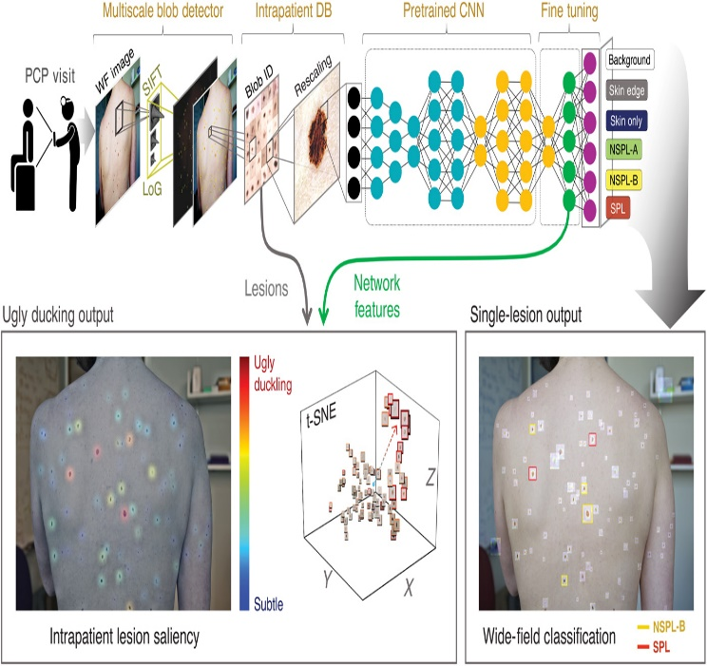

## Figure 5. CNN-Based Detection

## D. Convolution Neural Network

Skin cancer is a cancer that kills. Incomplete DNA repair in skin cells results in cancer and genetic alterations. Therefore, it is the best moment to locate it when it is still a baby. These challenges have led researchers to develop numerous early-detection methods for skin cancer. The symmetry, color, size, and shape of a lesion aid medical professionals in identifying and distinguishing between melanoma and skin cancer. The researcher conducted a study on automated skin cancer diagnosis due to these factors. Among the most promising methods is the application of machine learning. A recent study shows that skin cancer can be divided and analyzed using deep network topologies. More research is needed to evaluate if Deep Learning (DL) algorithms may be employed according to the results of this study. A review of high-quality research articles about skin cancer diagnosis published in reputable publications was conducted. [49]

The image-guided intervention uses digital technology to supply virtual picture overlays to aid surgeons in precisely visualizing and finding the surgical site. The use of Deep Learning (DL) methods in computer-aided diagnostic (CAD) models allows for the precise classification of skin cancer). The U-Net segmentation strategy then follows this. Also, a set of feature vectors is output by the SqueezeNet model. Skin cancer can be detected and classified by combining a DNN model with the Improved Whale Optimization Algorithm (IWOA). This approach makes efficient use of IWOA to choose the DNN parameters. With a maximum accuracy of 99.90%, the suggested ODNNCADSCC model outperformed previous techniques, according to the comparative analysis [50].

The article proposes an automated method of skin cancer classification. Nine distinct skin cancer types were identified in this investigation. Furthermore, deep CNNs efficacy and capacity are highlighted. This dataset includes information on nine distinct skin cancers: nevus, dermatofibroma, melanoma, benign keratosis, basal cell carcinoma, actinic keratosis, squamous cell carcinoma, and vascular lesions. The goal is to build a skin cancer detection and classification model using convolutional neural networks. The diagnostic procedure makes use of ideas from deep learning and image processing. Using various picture augmentation techniques has also led to a rise in the quantity of photos. In conclusion, the transfer learning approach further enhances the accuracy of classification tasks. On average, the proposed CNN method achieves 79.45% accuracy, 0.76 weighted average f1-score, 0.78 weighted average recall, and 0.76 weighted average precision [51].

The literature surveys delve into the application of Artificial Intelligence (AI) and Machine Learning (ML), particularly Deep Learning (DL) and Convolutional Neural Networks (CNNs), in the early detection and classification of skin cancer. They highlight innovative AI approaches in digital pathology, showcasing their potential to offer insights for treatment guidance and biomarker development in clinical oncology. ML-based systems, including mobile applications, demonstrate promising results in skin cancer detection, providing faster and more accurate diagnoses. Deep learning methods, including Convolutional Neural Networks (CNNs), are effective in categorizing different types of skin cancer and identifying different lesions. Model accuracy is improved by utilizing transfer learning and data augmentation approaches. Challenges such as data reliability, model interpretability, and algorithm trustworthiness continue to exist and need to be resolved for extensive use in clinical settings. The literature emphasizes the significant impact of AI and ML in enhancing early detection and treatment results for skin cancer while recognizing the necessity for additional research to address current obstacles.

III. Discussion

It is crucial to emphasize the potential impact of AI-driven skin cancer detection on improving patient outcomes. By leveraging deep learning techniques like convolutional neural networks (CNNs), the research demonstrates how advanced technology can play a pivotal role in early intervention and diagnosis. The thorough analysis of various literature surveys sheds light on the promising capabilities of AI models in accurately identifying and classifying different types of skin cancer. This highlights the potential of AI as a reliable tool for healthcare practitioners to make timely and accurate diagnostic decisions. However, while the results are promising, it is important to acknowledge the existing challenges and limitations. One such challenge is the need for further validation and exploration of the AI models, particularly in diverse populations. This ensures the models are robust and effective across different demographic groups, considering skin type variations, genetic background, and environmental factors.

Moreover, data reliability, model interpretability, and algorithm trustworthiness must be addressed to facilitate the widespread adoption of AI-driven skin cancer detection in clinical practice. Ensuring the reliability and accuracy of the data used to train these models is essential for their effectiveness in real-world scenarios. Additionally, making AI models interpretable and transparent to healthcare practitioners is crucial for building trust and confidence in their use. By incorporating diverse technique analyses, the research provides a nuanced understanding of the strengths and areas for improvement in AI-driven skin cancer detection. This comprehensive approach contributes to advancing dermatological research and underscores the importance of continued efforts in this field.

Continuing research and development in the intersection of artificial intelligence and dermatology hold promise for further enhancements in skin cancer detection. Collaborative efforts between researchers, healthcare professionals, and technology experts will be key to realizing the full potential of AI in improving healthcare outcomes for patients with skin cancer.

Table I. Summary of Literature Survey

|  |  |  |  |  |  |  |
| --- | --- | --- | --- | --- | --- | --- |
| Ref. No | Category | Title | Description | Methodology | Key Findings | Limitations and Future Scope |
| [12] | Artificial Intelligence | AI-driven Skin Cancer Detection: Innovations and Challenges | Explores the impact of AI on skin cancer detection, including innovative approaches and challenges | Literature review, case studies | AI offers promising advancements in skin cancer detection, but challenges in integration and validation remain. | Further research is needed to address validation issues and ensure seamless integration into clinical practice. |
| [14] | Artificial Intelligence | AI Algorithm for Skin Lesion Classification | Discusses the implementation of an AI algorithm for classifying skin lesions and its integration into clinical practice. | Pre- and post-intervention trial, comparison | AI lesion evaluations show potential for improving diagnosis, but validation against histology is essential for safety. | Future studies should focus on long-term safety and efficacy, as well as optimization of AI integration. |
| [17] | Artificial Intelligence | Survey of AI-based Cancer Prediction Techniques | Reviews the literature on AI-based methods for cancer prediction, highlighting challenges and suggesting areas for further research | Research publication search, survey | Current AI techniques show promise but have not yet significantly reduced cancer mortality. | Further investigation is needed to address the limitations and improve the effectiveness of AI-based cancer prediction. |
| [20] | Artificial Intelligence | AI-powered Skin Cancer Detection: Current Trends and Future Directions | Examines the potential of AI in skin cancer diagnostics, considering datasets, review articles and future research directions. | Meta-analysis, review of datasets | AI holds promise for early skin cancer detection, but more research is needed for widespread adoption. | Future research should address dataset limitations and improve AI algorithms' scalability. |
| [23] | Artificial Intelligence | Patient Perspectives on AI in Melanoma Diagnostics | Investigates patients' views on AI applications in melanoma diagnostics, revealing expectations and concerns | Survey, descriptive analysis | Patients generally have a favorable view of AI in melanoma diagnostics, but concerns about privacy and trust remain. | Future studies should explore addressing patient concerns and improving AI communication in healthcare settings. |
| [25] | Artificial Intelligence | Impact of Mobile Health Apps with AI on Dermatological Healthcare Usage | Analyzes the effect of a mobile health app with AI on dermatological healthcare usage, highlighting cost-effectiveness and outcomes. | Retrospective study, cost-effectiveness analysis | The app improves the detection of (pre)malignant lesions but increases utilization for benign conditions. | Further evaluation is needed to balance benefits and costs, especially benign conditions. |
| [27] | Artificial Intelligence | AI-based Detection of Melanoma | Explores an AI-based approach for melanoma detection using deep learning techniques, emphasizing model accuracy and future applications. | Dataset creation, deep learning model development | The MobileNet model shows promising accuracy for melanoma detection, with potential applications in clinical practice. | Future research should focus on real-world validation and integration into clinical workflows. |
| [28] | Artificial Intelligence | Role of AI in Early Cancer Detection and Prevention | Discusses the potential of AI in early cancer detection, emphasizing its role in preventive healthcare and improving patient outcomes. | Review of literature, discussion | AI shows potential to improve early cancer detection, but challenges in implementation and validation remain. | Future efforts should focus on overcoming implementation barriers and ensuring seamless integration into healthcare systems. |
| [30] | Artificial Intelligence | Advancements in AI-assisted Skin Cancer Diagnosis and Treatment | Reviews recent advancements in AI-assisted skin cancer diagnosis and treatment, highlighting the transformative impact on healthcare. | Review of recent studies, analysis | AI technologies have improved skin cancer diagnosis and treatment, improving patient outcomes. | Further research should address challenges in real-world implementation and optimize AI integration into clinical workflows. |
| [31] | Artificial Intelligence | Systematic Review of AI/ML Algorithms for Skin Cancer Diagnosis in Primary Care Settings | Provides a systematic review of AI/ML algorithms for skin cancer diagnosis in primary care, highlighting diagnostic accuracy and future considerations. | The systematic review, analysis | AI/ML algorithms show reasonable diagnostic accuracy for skin cancer, but further validation in primary care settings is needed. | Future research should focus on developing standardized protocols and guidelines for AI implementation in primary care. |
| [32] | Machine Learning | Mobile App for Skin Cancer Detection using ML | Discusses the development of a mobile app for skin cancer detection using machine learning, offering new opportunities for research and development. | App development, evaluation | The app provides a user-friendly interface and accurate results for skin cancer detection, showing potential for widespread use. | Future iterations should improve user experience and expand the app's capabilities. |
| [33] | Machine Learning | Integration of AI into Dermatology for Skin Imaging Collaboration | Explores the integration of AI into dermatology, emphasizing the need for global collaboration in skin imaging data collection and analysis | Collaboration with dermatologists, data collection | AI integration in dermatology improves skin imaging collaboration, enhancing diagnostic accuracy and efficiency. | Future efforts should focus on establishing data-sharing protocols and addressing data privacy concerns. |
| [34] | Machine Learning | Transformative Impact of AI and ML in Oncology | Examines the transformative impact of AI and ML in oncology, highlighting advancements in cancer detection, prognosis, and treatment | Review of recent studies, analysis | AI and ML have revolutionized oncology, leading to more accurate diagnoses, personalized treatments, and improved patient outcomes. | Future research should focus on optimizing AI algorithms for specific cancer types and exploring new applications in oncology. |
| [35] | Machine Learning | Systematic Review of AI/ML Algorithms for Skin Cancer Diagnosis in Community Care Settings | Provides a systematic review of AI/ML algorithms for skin cancer diagnosis in community care settings, emphasizing diagnostic accuracy and future directions | The systematic review, meta-analysis | AI/ML algorithms promise skin cancer diagnosis in community care settings, but further validation is needed in diverse populations. | Future research should focus on addressing healthcare disparities and optimizing AI algorithms for community-based settings. |
| [36] | Deep Learning | Overfitting Issues in CNN-based Skin Cancer Diagnosis | Addresses overfitting issues in CNN-based skin cancer diagnosis, highlighting the need for optimization and future research directions. | Model development, analysis | CNN models show susceptibility to overfitting in skin cancer diagnosis, requiring further optimization for improved accuracy. | Future research should focus on developing regularization techniques and increasing dataset diversity to mitigate overfitting. |
| [37] | Deep Learning | Automated Systems for Skin Cancer Diagnosis and Classification | Compares automated systems with medical staff-based detection in skin cancer diagnosis, highlighting the potential of deep learning in early detection. | Comparative analysis, evaluation | Automated systems offer comparable performance to medical staff-based detection, showing promise for improving early diagnosis. | Future studies should focus on real-world validation and optimizing model performance across diverse patient populations. |
| [38] | Deep Learning | Systematic Review of AI in Dermatology | Summarizes the literature on AI in dermatology, focusing on convolutional neural networks and their potential applications in clinical practice. | A systematic review, literature analysis | CNNs show promise in dermatology for various applications, including skin cancer detection and classification, but further validation is needed. | Future research should focus on standardizing evaluation metrics and developing guidelines for AI implementation in dermatology. |
| [39] | Deep Learning | Development of Melanoma Detection System using DL | Investigates the feasibility of a tailored melanoma detection system using deep learning, emphasizing model accuracy and future research directions. | Model development, evaluation | The proposed deep learning model shows promising accuracy for melanoma detection, paving the way for future clinical applications. | Future research should focus on real-world validation and integration of the model into existing healthcare systems. |
| [40] | Deep Learning | Explainable AI for Skin Lesion Classification | Proposes an explainable AI model for skin lesion classification, emphasizing model interpretability and its potential impact on clinical practice. | Model development, explanation | Explainable AI models improve transparency in skin lesion classification, enhancing trust and facilitating clinical decision-making. | Future research should focus on optimizing model performance without sacrificing interpretability and exploring real-world implementation. |
| [41] | Deep Learning | Automated Methods for Skin Cancer Detection | Examines automated methods for skin cancer detection using deep learning, highlighting performance and future challenges. | Model development, evaluation | Automated methods show high performance in skin cancer detection but face challenges in real-world implementation and validation. | Future research should address these challenges and optimize model generalization across diverse populations. |
| [42] | Deep Learning | Novel DL Method for Cancer Diagnosis | Presents a novel deep learning method for cancer diagnosis using ultrasound images, emphasizing accuracy and potential applications in oncology. | Model development, evaluation | The proposed deep learning method shows promising accuracy in cancer diagnosis using ultrasound images, with potential applications in oncology. | Future research should focus on large-scale validation and integration into clinical practice to assess real-world effectiveness. |
| [43] | Deep Learning | Comprehensive Review of Neural Network Methods for Skin Cancer Diagnosis | Reviews various neural network methods for skin cancer diagnosis, discussing challenges and future research directions. | The systematic review, analysis | Neural network methods show promise for skin cancer diagnosis but face challenges in real-world implementation and validation. | Future research should optimize model performance and address data heterogeneity to improve diagnostic accuracy. |
| [44] | Deep Learning | AI-based Melanoma Classification in Individuals with Darker Skin Tones | Details the development of an AI system for melanoma classification in individuals with darker skin tones, emphasizing accuracy and data augmentation. | Model development, evaluation | The AI system demonstrates high accuracy in melanoma classification for individuals with darker skin tones, with data augmentation improving performance. | Future research should focus on increasing dataset diversity and addressing potential biases in the training data to improve model generalization. |
| [45] | Deep Learning | Challenges and Opportunities in AI-based Skin Cancer Detection | Explores challenges and opportunities in AI-based skin cancer detection, including data diversity, hardware implementation, and ethical considerations. | Analysis of challenges and opportunities | AI-based skin cancer detection offers immense potential but faces challenges related to data diversity, hardware limitations, and ethical concerns. | Future research should address these challenges and optimize AI algorithms for real-world implementation. |
| [46] | Deep Learning | Automated Methods for Skin Cancer Diagnosis | Investigates automated methods for skin cancer diagnosis using deep learning, addressing challenges and potential solutions. | Model development, evaluation | Automated methods show promise for skin cancer diagnosis but face challenges such as data scarcity and model interpretability. | Future research should address these challenges and optimize model performance for real-world applications. |
| [47] | Convolutional Neural Network | Automated Skin Cancer Diagnosis using Machine Learning | Investigates machine learning-based automated skin cancer diagnosis, highlighting the potential of convolutional neural networks in clinical practice. | Model development, evaluation | CNN-based automated diagnosis shows promise for skin cancer detection, with potential applications in clinical settings. | Future research should focus on large-scale validation and integration into clinical workflows to assess real-world effectiveness. |
| [48] | Convolutional Neural Network | Deep Learning Methods for Skin Cancer Classification | Explores deep learning methods for skin cancer classification, emphasizing dataset diversity and transfer learning techniques. | Model development, dataset analysis | Deep learning methods show promise for skin cancer classification, especially when trained on diverse datasets and using transfer learning. | Future research should focus on improving model generalization and validation in real-world clinical settings. |
| [49] | Convolutional Neural Network | Automated Skin Cancer Classification using CNN | Proposes an automated method for skin cancer classification using CNN, emphasizing accuracy and the potential for clinical application. | Model development, evaluation | The CNN-based classification method achieves high accuracy in skin cancer classification, showing potential for clinical use. | Future research should focus on optimizing model performance and integrating it into existing clinical workflows. |
| [50] | Convolutional Neural Network | Image-guided Intervention for Precise Skin Cancer Classification | Discusses image-guided intervention methods for precise skin cancer classification, highlighting the integration of deep learning and optimization techniques. | Model development, integration | Image-guided interventions enhance skin cancer classification accuracy, especially with deep learning techniques. | Future research should focus on validating these interventions in clinical settings and optimizing their integration into routine practice. |
| [51] | Convolutional Neural Network | Development of Skin Cancer Detection and Classification Model using CNN | Details the development of a skin cancer detection and classification model using CNN, emphasizing image processing techniques and model accuracy. | Model development, image processing | The CNN-based model demonstrates high accuracy in skin cancer detection and classification, showing promise for clinical use. | Future research should focus on large-scale validation and integration into existing healthcare systems for real-world impact. |

##### IV. Conclusion

This research delves into AI-driven skin cancer detection, leveraging the power of deep learning techniques. Through a meticulous analysis of various literature surveys employing different techniques, our study highlights the potential of convolutional neural networks in early intervention for skin cancer. The findings underscore the importance of accurate and timely diagnosis, showcasing the model's effectiveness in classifying different types of skin cancer. However, it is essential to acknowledge the limitations and challenges faced, including the need for further validation and exploration in diverse populations. Incorporating diverse technique analyses enriches the paper's contributions, providing a nuanced understanding of the strengths and areas for improvement in the proposed AI-driven approach. As we navigate the intersection of artificial intelligence and dermatological research, our work paves the way for continued advancements in skin cancer detection, ultimately contributing to enhanced healthcare outcomes.

##### References

1. G. D. Dakubo, "Circulating Tumor Cells and Cancer Stem Cells," in Cancer Biomarkers in Body Fluids, Springer International Publishing, 2016, pp. 205-231. DOI: 10.1007/978-3-319-01580-4_8.
2. "Cancer Research UK commends higher rates of earlier diagnosis to improve cancer survival," Cancer Nursing Practice, vol. 17, no. 01, p. 7, Feb. 2018.
3. L. J. Jilderda, L. Zhou, and F. Foijer, "Understanding How Genetic Mutations Collaborate with Genomic Instability in Cancer," Cells, vol. 10, no. 2, p. 342, Feb. 2021.
4. Y. Zhao, Z. Tao, L. Li, J. Zheng, and X. Chen, "Predicting biochemical-recurrence-free survival using a three-metabolic-gene risk score model in prostate cancer patients," BMC Cancer, vol. 22, no. 1, p. 239, Mar. 2022. DOI: 10.1186/s12885-022-09331-8.
5. S. Ansieau, A.-P. Morel, and A. Puisieux, "From where do Cancer-Initiating Cells Originate?" in Cancer Stem Cells Theories and Practice, InTech, 2011, DOI: 10.5772/14903.
6. Santos, D. (2022, February 4). Melanoma Skin Cancer Detection using Deep Learning. Cold Spring Harbor Laboratory. http://dx.doi.org/10.1101/2022.02.02.22269505
7. T. A. P. Lagaunne, "Estimation of crop residue cover in high-resolution RGB images using features from a pre-trained convolutional neural network," University of Missouri Libraries, doi: 10.32469/10355/91517.
8. "Squamous Cell Carcinoma Including Actinic Keratosis, Bowen's Disease, Keratoacanthoma, and Its Pigmented Variants," in Color Atlas of Melanocytic Lesions of the Skin. Springer Berlin Heidelberg, pp. 295-302, 10.1007/978-3-540-35106-1_42
9. V. Senthil, V. Shreyaa, and V. Kothandapany, "Deep learning and rules-based hybrid approach to improve the accuracy of early detection of skin cancer," Authorea, Inc., Dec 29, 2022.
10. N. Sengupta, S. C. Sarode, G. S. Sarode, and U. Ghone, "Scarcity of publicly available oral cancer image datasets for machine learning research," Oral Oncology, vol. 126, p. 105737, Mar. 2022.
11. J. Whittlestone, "AI and Decision-Making," in Future Morality, Oxford University Press, 2021, pp. 102-110.
12. Kirthika Senthil Kumar, Vanja Miskovic, Agata Blasiak, Raghav Sundar; Alessandra Laura Giulia Pedrocchi; Alexander T. Pearson, Md; Arsela Prelaj, Md and Dean Ho, "Artificial Intelligence in Clinical Oncology: From Data to Digital Pathology and Treatment," Asco Educational Book, 2023
13. J. Kaur, "Patient-Centric AI," in *Approaches to Human-Centered AI in Healthcare*, IGI Global, 2024, pp. 1-19.
14. Claire Felmingham, Samantha Macnamara, William Cranwell, Narelle Williams, Miki Wada, Nikki R Adler, Zongyuan Ge, Alastair Sharfe, Adrian Bowling, Martin Haskett, Rory Wolfe, Victoria Mar, "Improving Skin Cancer Management with Artificial Intelligence (Smarti): Protocol for A Preintervention/ Postintervention Trial of An Artificial Intelligence System Used as A Diagnostic Aid for Skin Cancer Management in A Specialist Dermatology Setting," BMJ Open 2022.
15. H. Sutton, "Recognize how your own patterns and choices affect interactions with others," The Successful Registrar, vol. 17, no. 10, p. 8, Nov. 2017.
16. G. Kaur and A. S. Arora, "Significant Advancements in Cancer Diagnosis Using Machine Learning," in Cancer Prediction for Industrial IoT 4.0: A Machine Learning Perspective, Chapman and Hall/CRC, 2021
17. Chaoyi Zhang, Jin Xu, Rong Tang, Jianhui Yang, Wei Wang, Xianjun Yu, and Si Shi, "Novel Research and Future Prospects of Artificial Intelligence in Cancer Diagnosis and Treatment," Journal of Hematology & Oncology, 2023
18. Y. Kawabata, "Early malignant melanoma, diagnosis and treatment," Skin Cancer, vol. 16, no. 2, pp. 211-221, 2001.
19. B. Murugan, "Skin Cancer Treatment with Emphasis on Nanotechnology," in Skin Cancer: Pathogenesis and Diagnosis, Springer Singapore, 2021, pp. 193-209.
20. Yogesh Kumar, Surbhi Gupta, Ruchi Singla, Yu‑Chen Hu, "A Systematic Review of Artificial Intelligence Techniques in Cancer Prediction and Diagnosis," Archives of Computational Methods in Engineering, 2022.
21. M. Jędryka, "Translational molecular research has established a novel clinical approach in endometrial cancer patients," Advances in Clinical and Experimental Medicine, vol. 32, no. 2, pp. 141-145, Jan 13, 2023.
22. A. G. A. Farag, N. F. Elnaidany, and M. M. S. El-Dien, "Immunohistochemical Expression of Leptin in Non Melanoma Skin Cancer," Journal of clinical and diagnostic research: JCDR, vol. 10, no. 8, pp. WC08-WC12, Aug. 2016.
23. Navneet Melarkode, Kathiravan Srinivasan, Saeed Mian Qaisar and Pawel Plawiak, "Ai-Powered Diagnosis of Skin Cancer: A Contemporary Review, Open Challenges and Future Research Directions," Mdpi Cancers 2023
24. H. L. Dreyfus, "Why Heideggerian AI failed and how fixing it would require making it more Heideggerian," Artificial Intelligence, vol. 171, no. 18, pp. 1137-1160, Dec. 2007
25. Tanja B. Jutzi, Eva I. Krieghoff-Henning, Tim Holland-Letz, Jochen Sven Utikal , Axel Hauschild, Dirk Schadendorf , Wiebke Sondermann, Stefan Frohling, Achim Hekler, Max Schmitt, Roman C. Maron And Titus J. Brinker, “Artificial Intelligence In Skin Cancer Diagnostics: The Patients’ Perspective”, Frontiers In Medicine, 2020
26. H. Shridhar, M. V. Sumalata, M. Thushara, D. N. Ashwini, M. Suma, R. Premananda, and S. S. Harakannanavar, "Development of Object Recognition Model Using Machine Learning Algorithms on MobileNet V2," International Journal of Advanced Networking and Applications, vol. 15, no. 02, pp. 5908-5914, 2023.
27. Anna M. Smak Gregoor, Tobias E. Sangers, Lytske J. Bakker, Loes Hollestein, Carin A. Uyl – De Groot, Tamar Nijsten and Marlies Wakkee, “An Artificial Intelligence Based App for Skin Cancer Detection Evaluated in A Population Based Setting”, Npj Digital Medicine, 2023
28. Hediye Orhan Id and Emrehan Yav¸San, "Artificial Intelligence-Assisted Detection Model for Melanoma Diagnosis Using Deep Learning Techniques," Mathematical Modelling and Numerical Simulation with Applications, 2023
29. N. Faujdar, R. Agrawal, and A. Agarwal, "Critical Analysis of Various Supervised Machine Learning Algorithms for Detecting Diabetic Retinopathy in Images," in Artificial Intelligence and Machine Learning Techniques in Image Processing and Computer Vision, Apple Academic Press, 2024, pp. 75-93.
30. R. Deepa, S. Arunkumar, V. Jayaraj, And A. Sivasamy, "Healthcare's New Frontier: Ai-Driven Early Cancer Detection for Improved Well-Being", AIP Advances 13, 115331, 2023
31. Vinay Mallikarjunaradhya, Jinal Mistry, "The Optimized Analysis for Early Detection of Skin Cancer Using Artificial Intelligence," Ijcrt, 2023
32. Navneet Melarkode, Kathiravan Srinivasan, Saeed Mian Qaisar and Pawel Plawiak, "Ai-Powered Diagnosis of Skin Cancer: A Contemporary Review, Open Challenges and Future Research Directions", Cancers 2023
33. Manu Goyal, Thomas Knackstedt, Shaofeng Yan, And Saeed Hassanpour, "Artificial Intelligence-Based Image Classification for Diagnosis of Skin Cancer: Challenges and Opportunities," Arxiv, 2020
34. Abdulrahman Takiddin; Jens Schneider; Yin Yang; Alaa Abd-Alrazaq; Mowafa Househ, "Artificial Intelligence for Skin Cancer Detection: A Scoping Review",  Journal of Medical Internet Research, 2021
35. Dr. D. Thamaraiselvi, V. Vasanth Adithya, V. Guru Sainath, "Skin Cancer Detection Using Machine Learning," Jetir, 2023
36. Kinnor Das, Clay J. Cockerell, Anant Patil, Paweł Pietkiewicz, Mario Giulini, Stephan Grabbe, and Mohamad Goldust, "Machine Learning and Its Application in Skin Cancer," Int. J. Environ. Res. Public Health 2021
37. Bo Zhang, Huiping Shi, Hongtao Wang, "Machine Learning and Ai in Cancer Prognosis, Prediction, And Treatment Selection: A Critical Approach," Journal of Multidisciplinary Healthcare, 2023
38. O T Jones, R N Matin, M Van Der Schaar, K Prathivadi Bhayankaram, C K I Ranmuthu, M S Islam, D Behiyat, R Boscott, N Calanzani, J Emery, H C Williams, F M Walter, "Artificial Intelligence and Machine Learning Algorithms for Early Detection of Skin Cancer in Community and Primary Care Settings: A Systematic Review", Digital-Health Vol Jun 4 2022
39. Sreevidya R. C., Jalaja G., Sajitha N, D. Lakshmi Padmaja, S. Nagaprasad, Kumud Pant, and Yekula Prasanna Kumar, "Role of Artificial Intelligence and Deep Learning in Easier Skin Cancer Detection Through Antioxidants Present in Food," Hindawi Journal of Food Quality Volume 2022
40. Gangatharan N, Muthumanickam S, Rajagopal R, Sudharsanam V, Sai Rakesh K V, Sanjive Kumaran B, "Enhancing Skin Cancer Diagnosis with Deep Learning-Based Classification", International Journal on Recent and Innovation Trends in Computing and Communication, 2023
41. Hyeon Ki Jeong, Christine Park, Ricardo Henao2 and Meenal Kheterpal, "Deep Learning in Dermatology: A Systematic Review of Current Approaches, Outcomes, And Limitations," Jid Innovations 2023
42. Hanlin Dong And Farnaz Farid, "A Deep Learning Based Patient Care Application for Skin Cancer Detection," Research Square, 2022
43. Natasha Nigar, Muhammad Umar, Muhammad Kashif Shahzad, Shahid Islam, And Douhadji Abalo, "A Deep Learning Approach Based on Explainable Artificial Intelligence for Skin Lesion Classification," Ieee Access, 2022
44. V. S. Saranya, Parasa Rajya Lakshmi, Cheepurupalli Raghuram, Syed Muqthadar Ali, Dr. Jayavarapu Karthik, U. Ganesh Naidu, "Matrix-Based Deep Learning Approach to Ai-Driven Cancer Detection, Personalized Treatment, And Ethical Consideration", Intelligent Systems and Applications in Engineering, 2023
45. Mehwish Dildar, Shumaila Akram, Muhammad Irfan, Hikmat Ullah Khan, Muhammad Ramzan, Abdur Rehman Mahmood, Soliman Ayed Alasdair, Abdul Hakeem M Saeed, Mohammed Olaythah Alraddadi and Mater Hussen Mahnashi, "Skin Cancer Detection: A Review Using Deep Learning Techniques", Mdpi Int. J. Environ. Res. Public Health 2021
46. Oluwatobi O. Kushimo, Ayodeji Olalekan Salau, Oladapo J. Adeleke & Doyinsola S. Olaoye, "Deep Learning Model to Improve Melanoma Detection in People of Color", Arab Journal of Basic and Applied Sciences, 2023
47. Maryam Naqvi, Syed Qasim Gilani, Tehreem Syed, Oge Marques, and Hee-Cheol Kim, "Skin Cancer Detection Using Deep Learning—A Review," Mdpi Diagnostics 2023
48. Mehwish Dildar, Shumaila Akram, Muhammad Irfan, H. Khan, Muhammad Ramzan, Abdur Rehman Mahmood, Soliman Ayed Alsaiari, Abdul Hakeem M Saeed, M. Alraddadi, M. Mahnashi, "Skin Cancer Detection: A Review Using Deep Learning Techniques," International Journal of Environmental Research and Public Health, 2021
49. Akepati Sankar Reddy and Gopinath M. P, "A Comprehensive Review on Skin Cancer Detection Strategies Using Deep Neural Networks," Journal of Computer Science 2022
50. Areej A. Malibari A, Jaber S. Alzahrani B, Majdy M. Eltahir C, Vinita Malik D E, Marwa Obayya F, Mesfer Al Duhayyim G, Aloísio V. Lira Neto H, Victor Hugo C. De Albuquerque, "Optimal Deep Neural Network-Driven Computer-Aided Diagnosis Model for Skin Cancer," Computers and Electrical Engineering, 2022

Noortaz Rezaoana, Mohammad Shahadat Hossain, Karl Andersson "Detection and Classification Of Skin Cancer By Using A Parallel CNN Model", IEEE, 2020.